Dear Parents:
I am assigning the students to create a portfolio to store their artwork. You will need one poster board paper and duct tape. Please write the name of the student on the portfolio but limit decorating with sticker since the students will be decorating it in class.
Instructions:
- Please fold up the poster in half horizontally.
- Use duct tape to close the sides of the poster. You may use duct tape to decorate and reinforce the bottom part. Please make sure that you leave an opening to store the artwork.
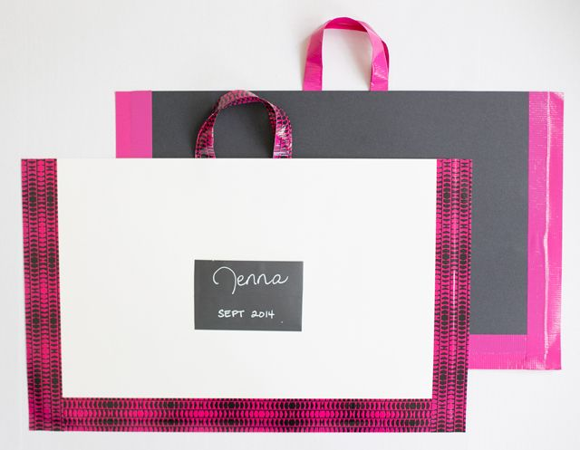
Tape on the bottom
Tape on the side
- Using the duct tape, you can create handles. You may also use string or any other material that is resistant to use as handles.
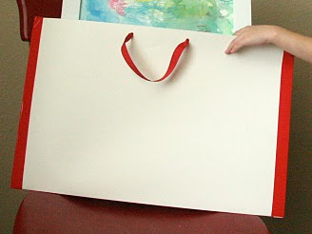
Duct tape was used to make the handle

