MackinVIA
- Go to: https://www.mackinvia.com/
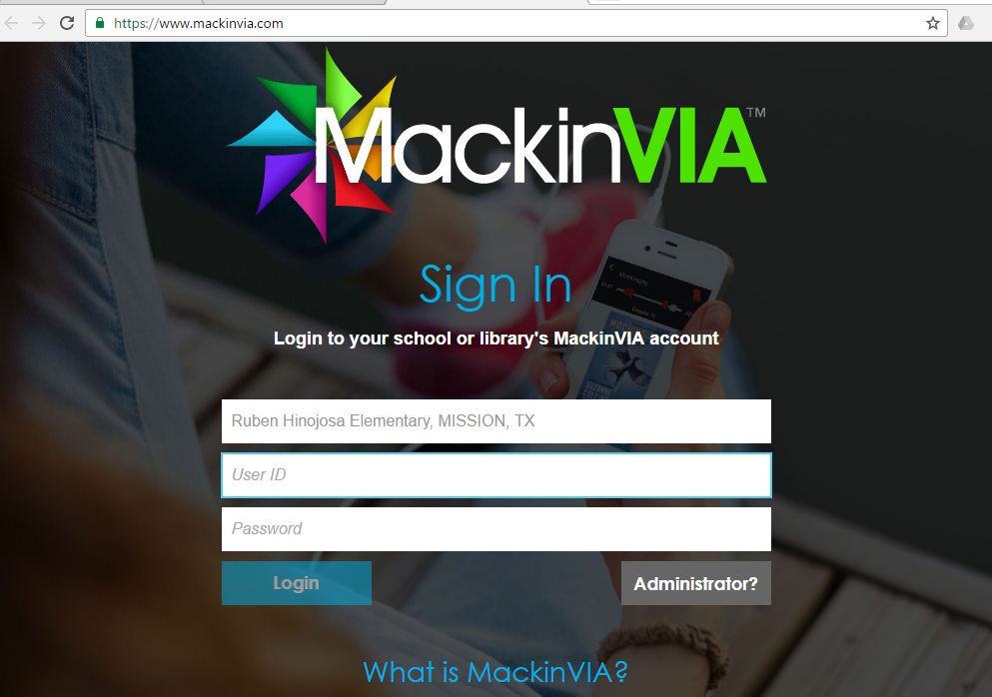
- Look up the school: Ruben Hinojosa Elementary, Mission TX

- Use student’s AR credentials for username and Password (This information is found inside the cover of their binder).
- Once you log in, you will see the following screen: 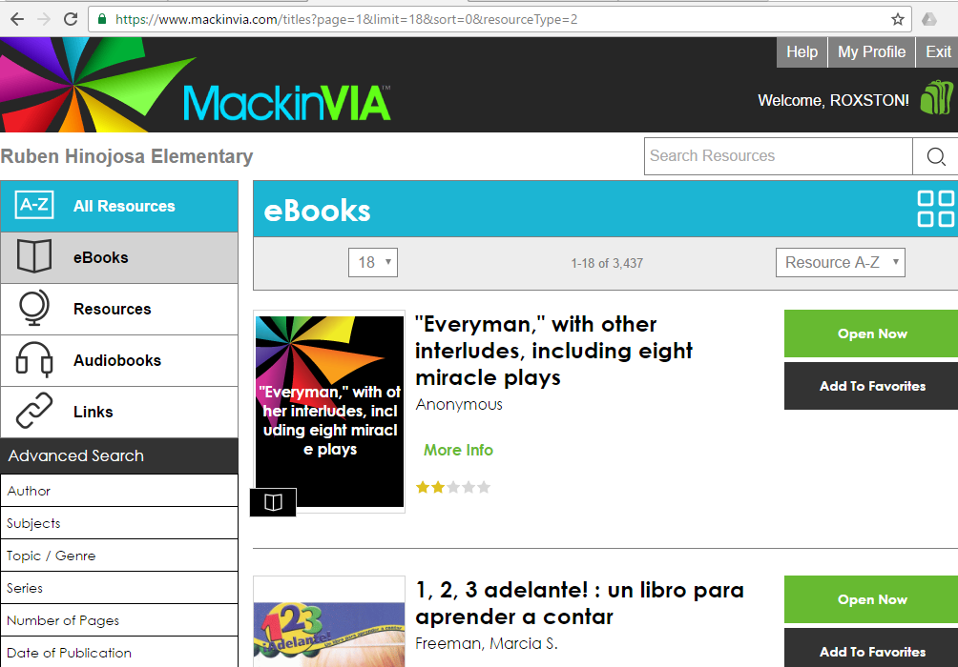
- Choose a book based on title or by the advanced search menu:
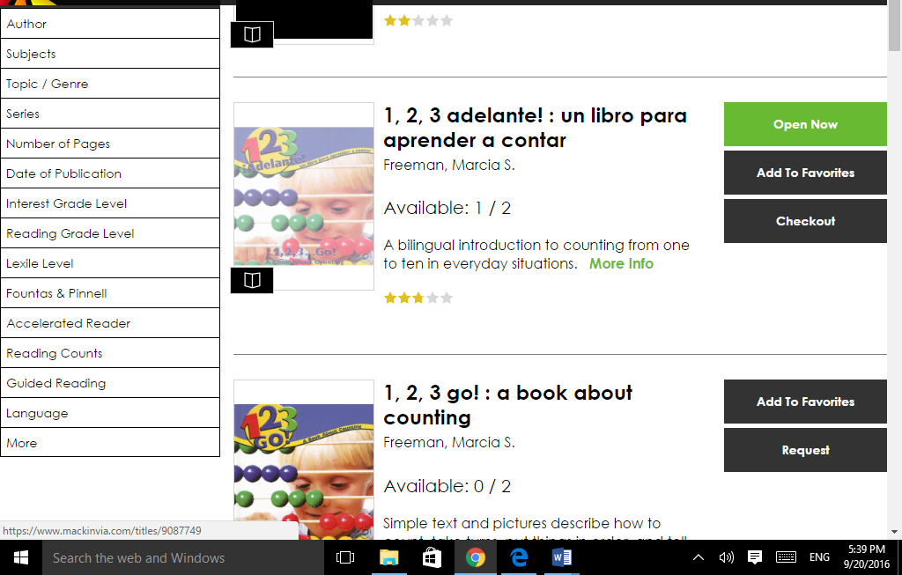

6. Once you have found the desired book, you will see this screen. Here you will see the Reading Lever, Quiz Number and AR points:
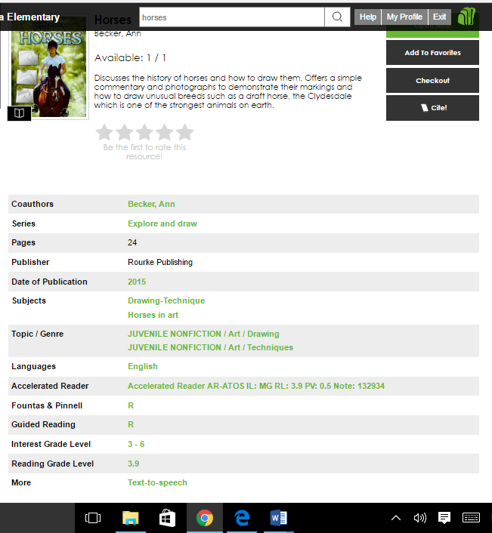
AR points
Reading Level
This is the AR quiz.

