Week 15
natural resources | A material found in nature that people and other living things use. | 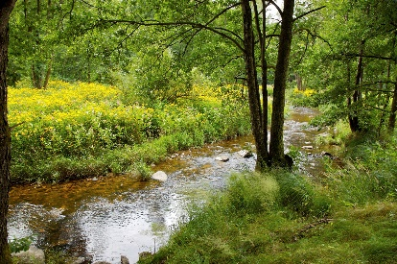
renewable resources | A natural resource that can be replaced within a reasonable amount of time | 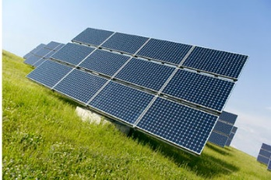
nonrenewable resources | A natural resources that cannot be replaced in a reasonable amount of time. | 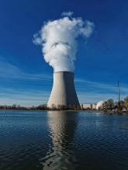
minerals | A nonliving solid with a crystal form. | 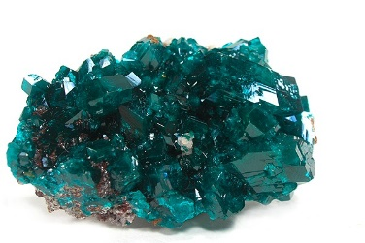
rock | A solid substance made of one or more minerals | 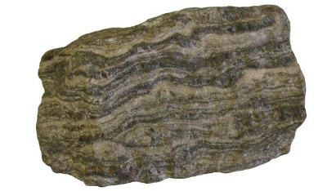
ore | A rock that is contains a valuable mineral. | 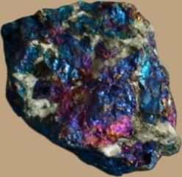
green energy | Energy generated using renewable resources.
watershed | All of the land and water that drain into a river system. | 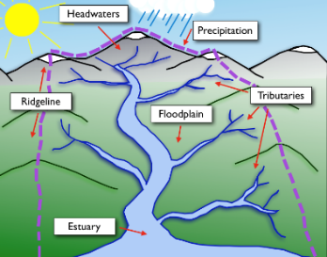
conservation | The use of less of something to make its supply last longer | 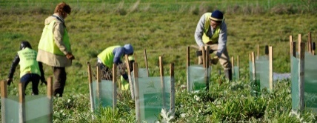
fossil fuels | Any organic material that came from a former life. | 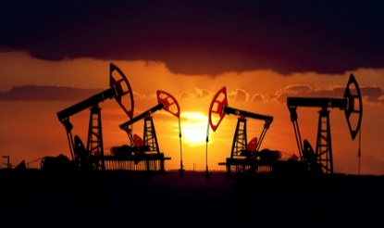
pollution | A substance or thing that has harmful or poisonous effects to the environment. | 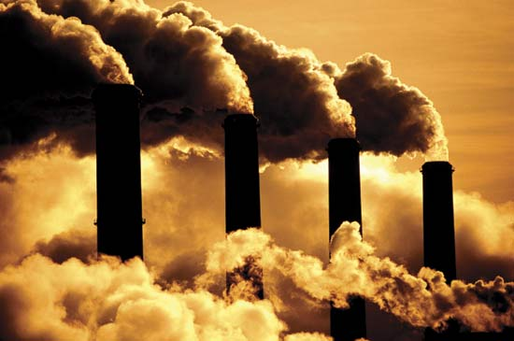
recycle | To covert waste into reusable material. | 