Week 25
food  chain | The transfer of food energy in a sequence of living things. | 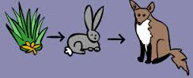
herbivore | A consumer that eats only plants or other producers. | 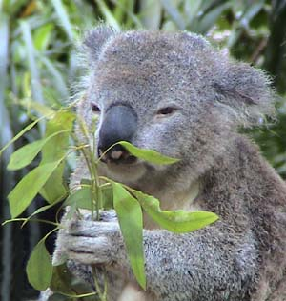
carnivore | A consumer that eats only other animals. | 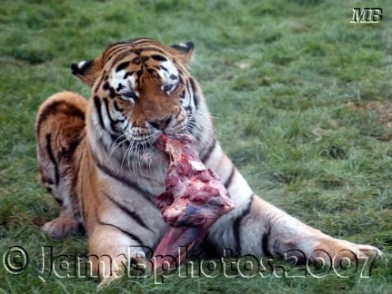
omnivore | A consumer that eats both plants and other animals. | 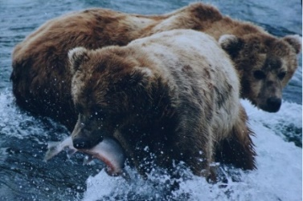
predator | An animal that hunts other animals. | 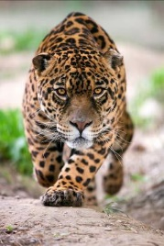
prey | Animals that are eaten. | 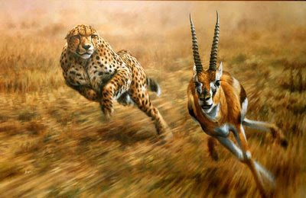
food  web | A diagram that shows the relationships among different food chains in an ecosystem. | 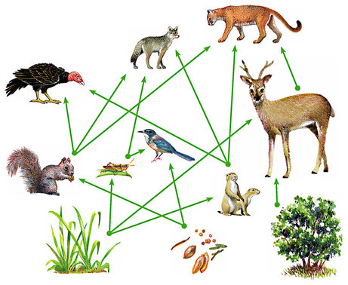
scavenger | Eats dead animals and plants. | 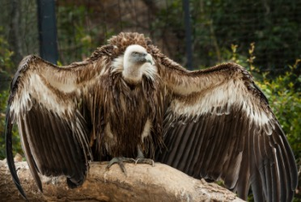
ecosystem | A system, or a group of elements, formed by a community of organisms with their environment. | 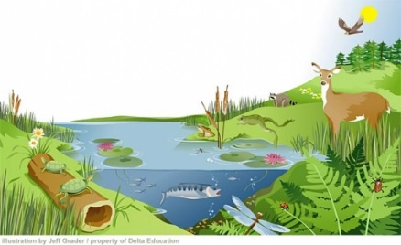
population | The body of inhabitants of a place. | 