Week 24
moon | A natural satellite of a planet; an object that revolves around a planet. | 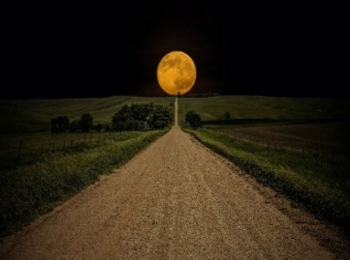
craters | The cup-shaped depression or cavity on the surface of the earth. | 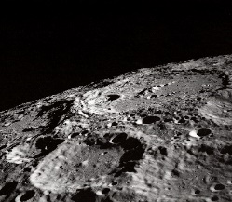
Maria | The plains on the moon’s surface. | 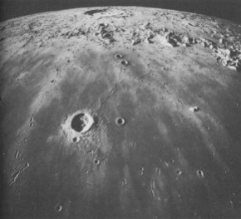
Gravity | A force that pulls objects toward each other. | 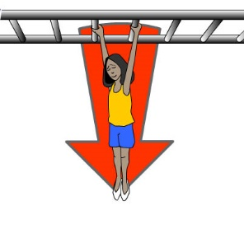
moon phases | A change in the appearance of the moon’s shape as it orbits Earth. | 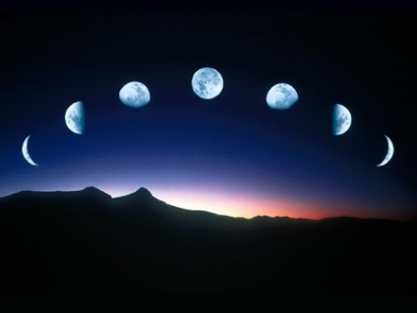
tide | The rise and call in the water level. | 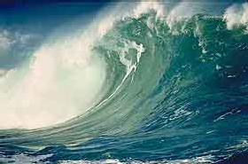
astronomer | An expert in astronomy; a scientific observer of the celestial bodies. | 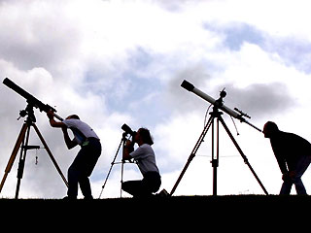
full moon | The phase of the moon in which its whole disk is illuminated | 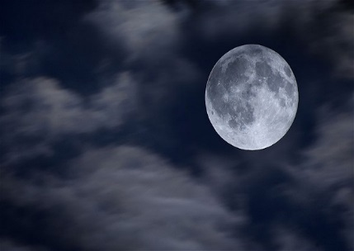
revolve | Earth does this around the sun once a year. | 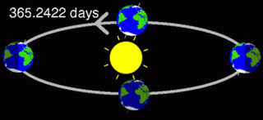
First quarter moon | During this phase of the moon fifty percent of it is illuminated and visible from the Earth. | 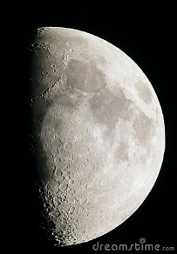
new moon | The moon either when in conjunction with the sun or soon after, being either invisible or visible only as a slender crescent | 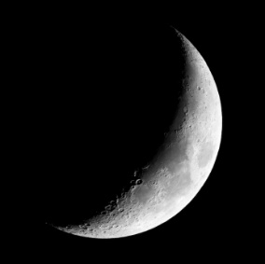
Third quarter moon | One-half illuminated by the sun. | 