Week 11
Energy | The ability to cause change in matter.
kinetic energy | The energy of motion.
potential energy | The energy something has because of its position or condition. | 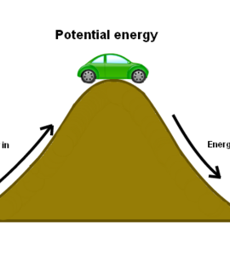
chemical energy | A form of energy that can be released by a chemical change.
Thermal  Energy | The total kinetic energy of the particles in a substance. | 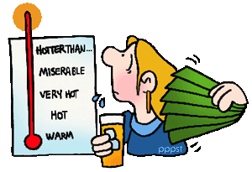
Mechanical Energy | The total potential energy and kinetic energy of an object. | 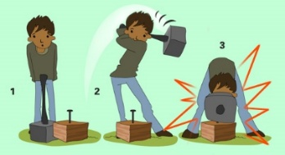
Light  Energy | Energy that can travel through space. | 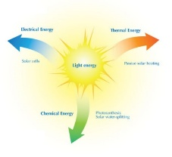
Chemical  Energy | A form of energy can be released by a chemical change. | 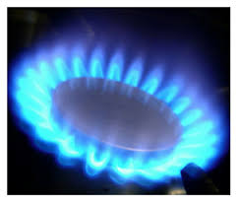
Electrical  Energy | A form of energy that comes from electric current. | 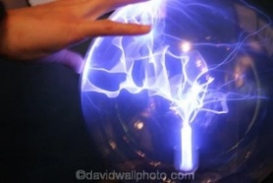
Heat | Energy that moves between objects at different types of temperatures. | 